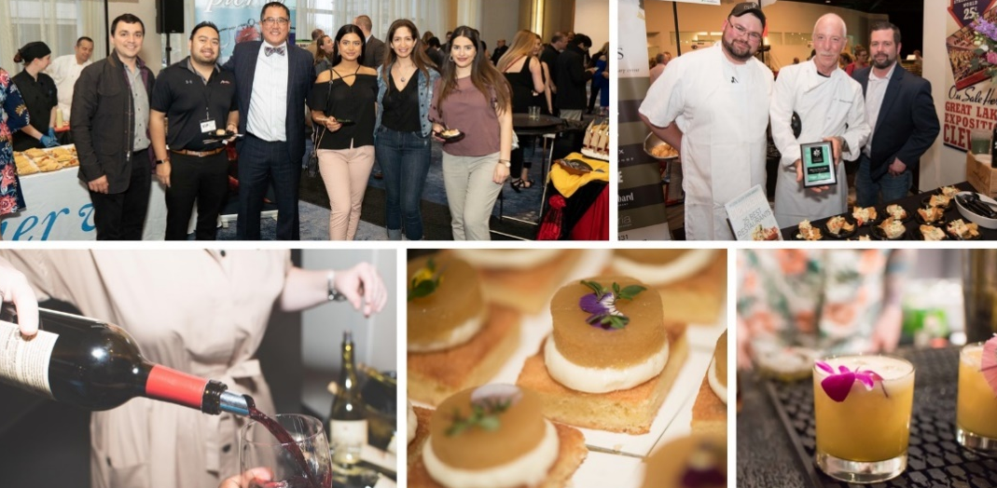
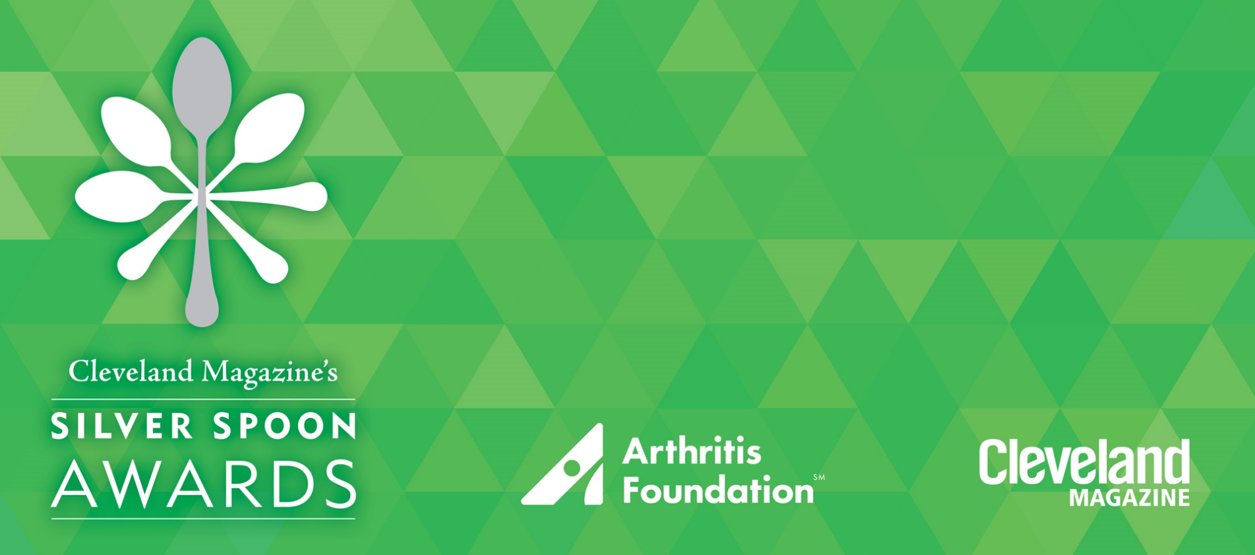

2024 Sponsorship Opportunities

All proceeds benefit the Arthritis Foundation

Cleveland Magazine’s Silver Spoon Awards
Wednesday, May 15, 2024 – 6:00pm
Cleveland Browns Stadium

clevelandmagazine.com/SilverSpoon

Cleveland Magazine and the Arthritis Foundation
are pleased to invite you to partner with us at
Cleveland’s outstanding social and culinary evening.

Guests indulge in delicious signature dishes from Northeast Ohio’s best restaurants and international wineries. Participating restaurants are
Cleveland Magazine Silver Spoon Award winners and finalists.

ABOUT THE ARTHRITIS FOUNDATION

The Arthritis Foundation helps people live their best life by creating a powerful network of support through shared experiences, empowering information, and meaningful connections. Whether it is online or in person, we are all working together to promote life-changing resources and research, to push for change and to create community connections that welcome, inform and uplift. This is what makes our community of millions thrive and why we are all Champions of Yes.

By advancing research, advocacy and disease management support, the Arthritis Foundation helps people navigate the many challenges arthritis brings.

- Arthritis is the nation’s #1 cause of disability affecting nearly 60 million Americans (1 in 4) including 300,000 children.

- It does not discriminate by age or ethnicity, and it costs our economy a staggering $304 billion annually in medical costs and lost earnings.

- We are boldly pursuing a cure for arthritis, while championing the fight to conquer chronic pain with life-changing resources, science, advocacy, & community connections.

BENEFITS OF YOUR CORPORATE SUPPORT
- Position your brand and create connections with consumers and local entrepreneurs.

- Align with a results-driven organization, your support makes an immediate impact.

- Showcase your commitment by aligning with the nation’s leading organization dedicated to conquering the disease that affects 1 in 4 of your employees.

SPONSORSHIP OPPORTUNTIES

PRESENTING SPONSOR $12,000 ($8,160 tax-deductible)

- Recognition as Presenting Sponsor throughout the 2024 event season
- Onstage speaking opportunity for company executive at event
- Includes admission, dinner, cocktails, and seating for 20 guests at 2 prominent tables
- Logo featured on all event marketing materials including website, signage, e-invitation, emails, social media posts, and Cleveland Magazine event advertisements
- Sponsor recognition during event (verbal and visual)

DESSERT SPONSOR $7,500 ($6,420 tax deductible)
- Includes admission, dinner, cocktails, and seating for 10 guests at 1 prominent, reserved table
- Logo on event dessert napkins
- Plus, all Presenting Sponsor marketing benefits

VALET SPONSOR $7,500 ($6,420 tax deductible)
- Includes admission, dinner, cocktails, and seating for 10 guests at 1 prominent, reserved table
- Opportunity to provide company-branded material to each guest
- Plus, all Presenting Sponsor marketing benefits

BATTLE OF THE LAND SPONSOR $5,000 ($2,080 tax deductible)
- Includes admission, dinner, cocktails, and seating for 10 guests at 1 prominent, reserved table
- Opportunity for guest/table interaction with on-stage Battle of the Land participants
- Plus, all Presenting Sponsor marketing benefits

REGISTRATION SPONSOR $4,000 ($2,848 tax-deductible)
- Includes admission, dinner, cocktails, and seating for 10 guests at 1 reserved table
- Logo on event day registration signage and sponsor recognition during event (verbal and visual)

LIVE AUCTION SPONSOR $4,000 ($2,848 tax deductible)
- Includes admission, dinner, cocktails, and seating for 10 guests at 1 reserved table
- Logo on 500 bidder paddles, auction signage, and sponsor recognition during event (verbal and visual)

SILENT AUCTION SPONSOR $4,000 ($2,080 tax deductible)
- Includes admission, dinner, cocktails, and seating for 10 guests at 1 reserved table
- Logo at event on silent auction package descriptions, auction signage, and sponsor recognition during event (verbal and visual)

ARTHRITIS ALLY $3,500 ($1,580 tax deductible)
- Includes admission, dinner, cocktails, and seating for 10 guests at 1 reserved table
- Table sign (logo or name) and recognition during the event (verbal and visual)

COUPLE ADMISSION $600 ($216 tax deductible)
- Silver Spoon Experience that includes admission, dinner, cocktails, and reserved seating for 2 guests

INDIVIDUAL ADMISSION $300 ($192 tax deductible)
- Silver Spoon Experience that includes admission, dinner, cocktails, and reserved seating for 1 guest

2024 SPONSORSHIP RESPONSE FORM

The level of sponsorship chosen is: ____________________________________________________________

Donation: $_______________________________

To purchase individual tickets, please visit clevelandmagazine.com/SilverSpoon

Company Name |  |  | Contact
Address
City |  | St |  | Zip
Phone |  |  | Email
Signature |  |  | Date
Payment Method
_____ Check enclosed (payable to the Arthritis Foundation)
_____ Please invoice us at the address provided above.
_____ Please charge the following credit card number in the amount of $

Account Number: ______________________________________________________________
Exp: _______________________
Card Type: AMEX VISA Discover MasterCard

Signature: ______________________________________________________________________
Date: __________________

Contact: Anne Reitzes, Executive Director
Arthritis Foundation, Northeast Ohio
areitzes@arthritis.org • 330-967-2723

Arthritis Foundation Mail Center Address: Arthritis Foundation c/o Arthritis Foundation Cleveland
1355 Peachtree Street, Suite 600 • Atlanta, Georgia 30309

